IMAGE QUALITY ASSESSMENT FOR OPTICAL CHARACTER RECOGNITION (OCR)
Comparative Analysis of ChatGPT-based Image Quality Assessment and Proposed OCR IQA Module
Abstract -
This document presents a comparative analysis of Image Quality Assessment (IQA) scores generated through ChatGPT's visual assessment and the proposed OCR IQA module for various document images.
Prepared By:- Vivek kumar rai
Centre for Development of Advanced Computing (C-DAC), Noida
July 2026

Original image | Image quality assessment score by chatgpt | Image Quality Assessment Score by model
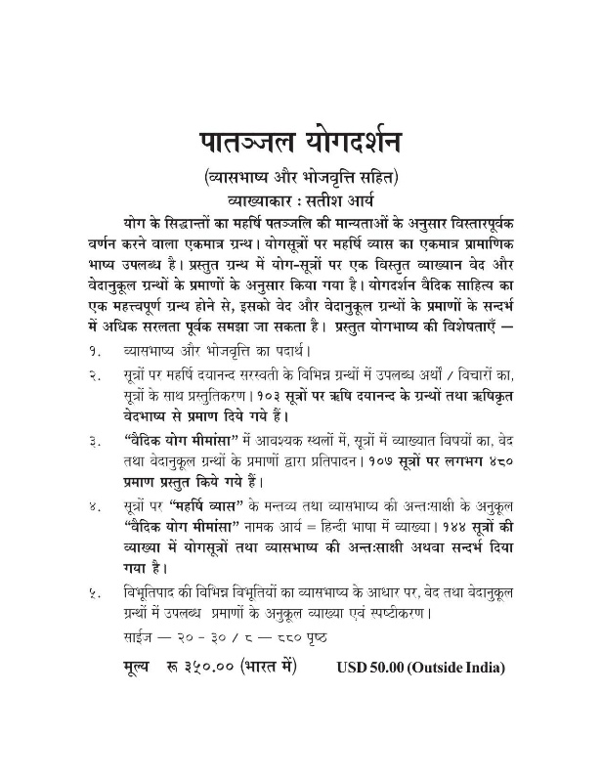 | Factor Score  Noise 99.7  Resolution 84.0  Blur 98.5  Contrast 89.0  Text Density 68.0  Stroke Width 87.0  Matra Continuity 94.0  CC Stability 90.0  Zone Integrity 95.0  Skew 100.0  Overall IQA 90.6 | Factor Score  Noise 98.0  Resolution 100.0  Blur 96.7  Contrast 80.6  Text Density 63.6  Stroke Width 95.1  Matra Continuity 66.4  Connected Components 48.5  Zone Integrity 76.8  Skew Detection 98.7  Overall IQA 83.4
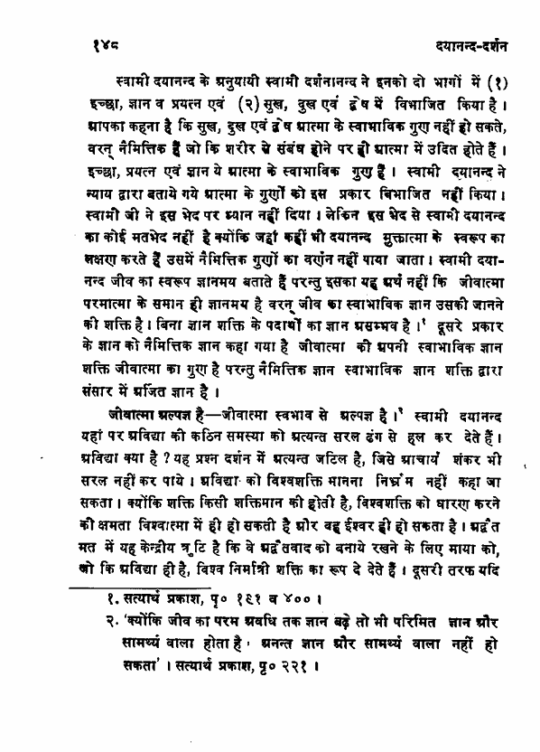 | Factor Score  Noise 99.6  Resolution 83.0  Blur 98.8  Contrast 87.5  Text Density 76.0  Stroke Width 88.0  Matra Continuity 91.5  CC Stability 89.0  Zone Integrity 93.0  Skew Detection 100.0  Overall IQA 91.1 | Factor Score  Noise 100.0  Resolution 44.9  Blur 100.0  Contrast 90.0  Text Density 88.1  Stroke Width 83.6  Matra Continuity 67.0  CC Stability 73.1  Zone Integrity 89.5  Skew Detection 98.4  Overall IQA 84.8
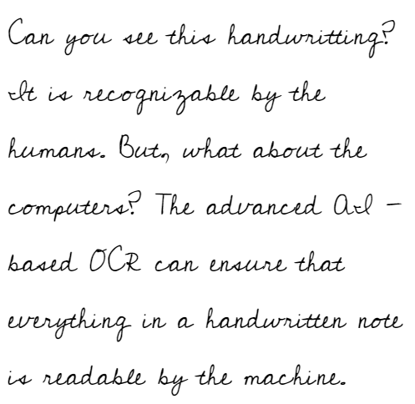  ------------------------------------------------------------  The three factors causing almost all of the gap are:  - Resolution  - Contrast  - Matra Continuity | Factor Score  Noise 99.2  Resolution 85.0  Blur 96.8  Contrast 88.5  Text Density 72.0  Stroke Width 82.0  Character Continuity* 90.0  CC Stability 84.0  Zone Integrity 91.0  Skew Detection 99.5  Overall IQA 89.2 | Factor Score  Noise 100.0  Resolution 28.1  Blur 100.0  Contrast 52.1  Text Density 62.4  Stroke Width 83.6  Matra Continuity 67.3  CC Stability 72.4  Zone Integrity 83.9  Skew Detection 100.0  Overall IQA 75.1  The real issue is the scoring algorithms
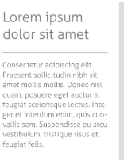  ------------------------------------------------------------  Almost the entire overall difference comes from only three metrics.  Resolution  Contrast and matra continuity | Factor Score  Noise 99.4  Resolution 56.0  Blur 78.5  Contrast 74.0  Text Density 69.0  Stroke Width 71.0  Character Continuity* 82.0  CC Stability 79.0  Zone Integrity 84.0  Skew Detection 100.0  Overall IQA 79.8 | Factor Score  Noise 100.0  Resolution 3.7  Blur 77.9  Contrast 25.5  Text Density 79.8  Stroke Width 83.6  Matra Continuity 53.7  CC Stability 64.5  Zone Integrity 87.5  Skew Detection 100.0  Overall IQA 67.6  The real issue is the scoring algorithms
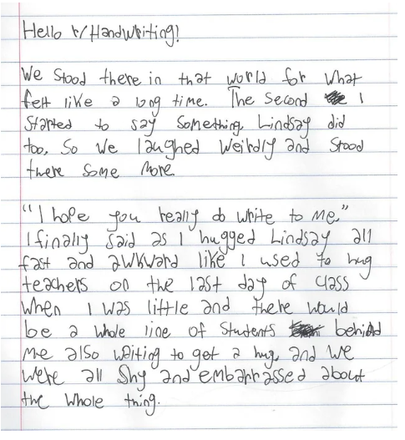 | Factor Score  Noise 98.8  Resolution 87.0  Blur 95.5  Contrast 91.0  Text Density 74.0  Stroke Width 80.0  Character Continuity* 87.0  CC Stability 79.0  Zone Integrity 89.0  Skew Detection 99.8  Overall IQA 88.6 | Factor Score  Noise 98.5  Resolution 29.8  Blur 94.3  Contrast 48.4  Text Density 70.6  Stroke Width 83.6  Matra Continuity 56.5  CC Stability 64.2  Zone Integrity 80.4  Skew Detection 100.0  Overall IQA 72.6
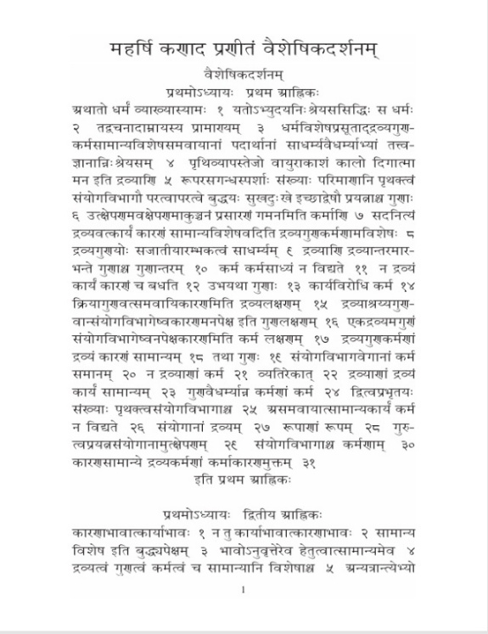  ------------------------------------------------------------  Almost the entire overall difference comes from only 4 metrics.  Resolution  Contrast  matra continuity and cc stability | Factor Score  Noise 99.8  Resolution 84.0  Blur 99.0  Contrast 90.0  Text Density 88.0  Stroke Width 85.0  Matra Continuity 92.0  CC Stability 90.0  Zone Integrity 95.0  Skew Detection 100.0  Overall IQA 91.8 | Factor Score  Noise 99.8  Resolution 47.6  Blur 100.0  Contrast 71.8  Text Density 70.0  Stroke Width 83.6  Matra Continuity 58.6  CC Stability 48.1  Zone Integrity 84.4  Skew Detection 100.0  Overall IQA 76.9  The real issue is the scoring algorithms
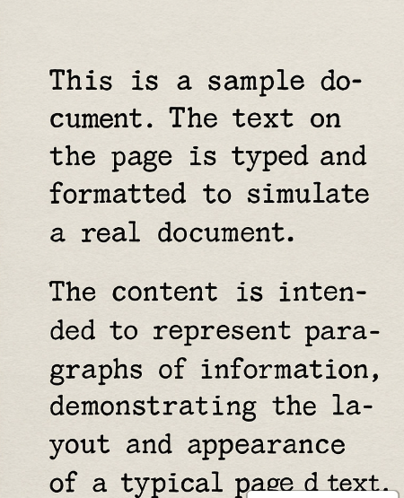 | Factor Score  Noise 96.5  Resolution 80.0  Blur 98.0  Contrast 86.0  Text Density 75.0  Stroke Width 87.0  Character Continuity 95.0  CC Stability 92.0  Zone Integrity 94.0  Skew Detection 100.0  Overall IQA 90.0 | Factor Score  Noise 94.5  Resolution 29.1  Blur 100.0  Contrast 85.0  Text Density 77.2  Stroke Width 96.1  Matra Continuity 70.1  CC Stability 87.1  Zone Integrity 91.0  Skew Detection 100.0  Overall IQA 81.2
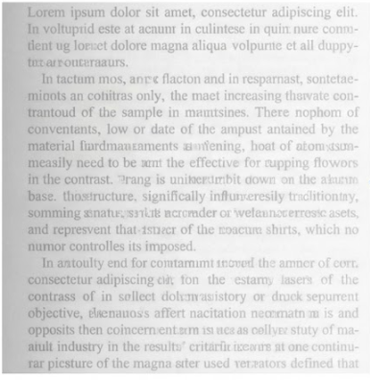  Almost the entire overall difference comes from only 4 metrics.  Resolution  Text dencity  Stroke width  cc stability | Factor Score  Noise 91.0  Resolution 58.0  Blur 72.0  Contrast 34.0  Text Density 89.0  Stroke Width 62.0  Character Continuity 70.0  CC Stability 68.0  Zone Integrity 75.0  Skew Detection 100.0  Overall IQA 69.8 | Factor Score  Noise 97.1  Resolution 17.8  Blur 59.5  Contrast 22.8  Text Density 49.7  Stroke Width 83.6  Matra Continuity 64.7  CC Stability 0.0  Zone Integrity 51.4  Skew Detection 100.0  Overall IQA 54.3  The real issue is the scoring algorithms
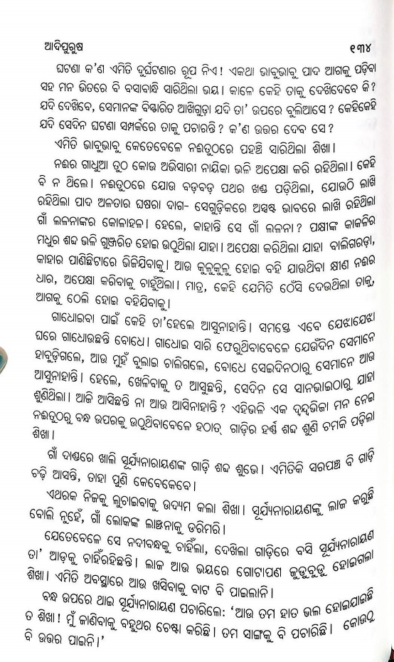 | Factor Score  Noise 99.4  Resolution 76.0  Blur 98.0  Contrast 87.0  Text Density 85.0  Stroke Width 84.0  Character Continuity 91.0  CC Stability 89.0  Zone Integrity 93.0  Skew Detection 100.0  Overall IQA 89.9 | Factor Score  Noise 97.5  Resolution 100.0  Blur 95.2  Contrast 100.0  Text Density 79.1  Stroke Width 87.7  Matra Continuity 64.3  CC Stability 78.7  Zone Integrity 72.6  Skew Detection 89.4  Overall IQA 87.7
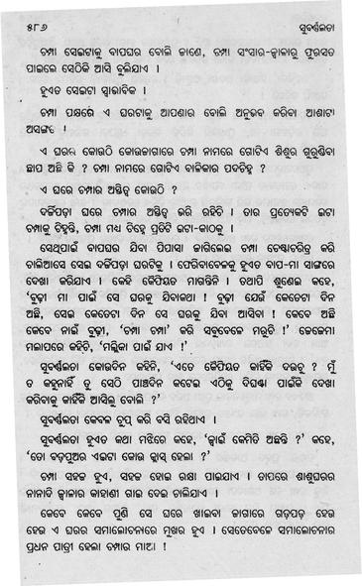 | Factor Score  Noise 97.8  Resolution 75.0  Blur 95.0  Contrast 82.0  Text Density 84.0  Stroke Width 83.0  Character Continuity 89.0  CC Stability 86.0  Zone Integrity 91.0  Skew Detection 99.5  Overall IQA 88.0 | Factor Score  Noise 90.3  Resolution 25.2  Blur 100.0  Contrast 85.0  Text Density 85.1  Stroke Width 83.6  Matra Continuity 64.6  CC Stability 69.3  Zone Integrity 96.5  Skew Detection 97.6  Overall IQA 79.8

